The experimental procedures involving human subjects described in this work were approved under UTD IRB # 11-59 by the Institutional Review Board at the University of Texas at Dallas, Richardson, Texas, USA.

The Dataset consists of two experiments as explained below:

- Experiment 1:
1. Data is collected using Vista Medical FSA SoftFlex 2048
2. Size of pressure mat is 32*64. This is the raw data collected reporting numbers in range of [0-1000] for each sensor.
3. Sampling rate is 1Hz.
4. Each file includes the data frames around 2-mins (around 120 frames).

- Subject properties:

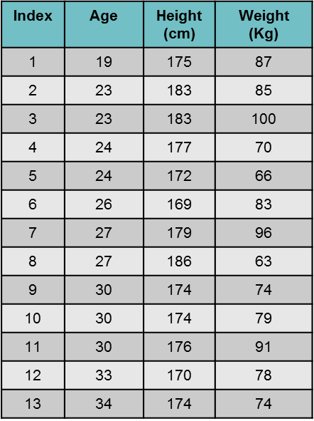
- Data properties:
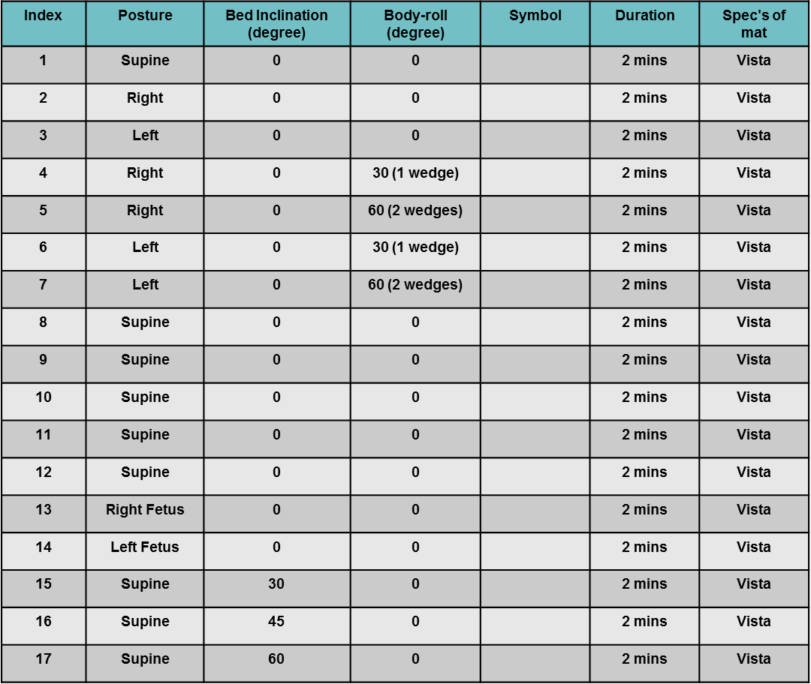

- Experiment 2:
1. Data is collected using Vista Medical BodiTrak BT3510
2. Size of pressure mat is 27*64. This is the raw data collected reporting numbers in range of [0-500] for each sensor.
3. Sampling rate is 1Hz.
4. Each file contains the average of around 20 frames
5. The data is collected for both sponge and air mattresses separately.

- Subject properties:

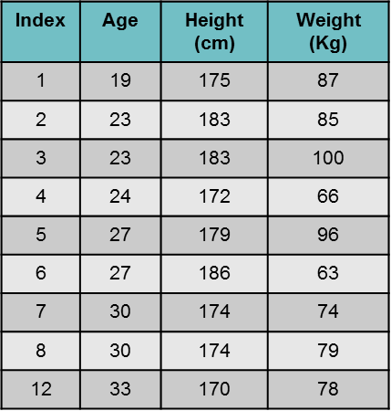

- Data properties:

  - Part B:

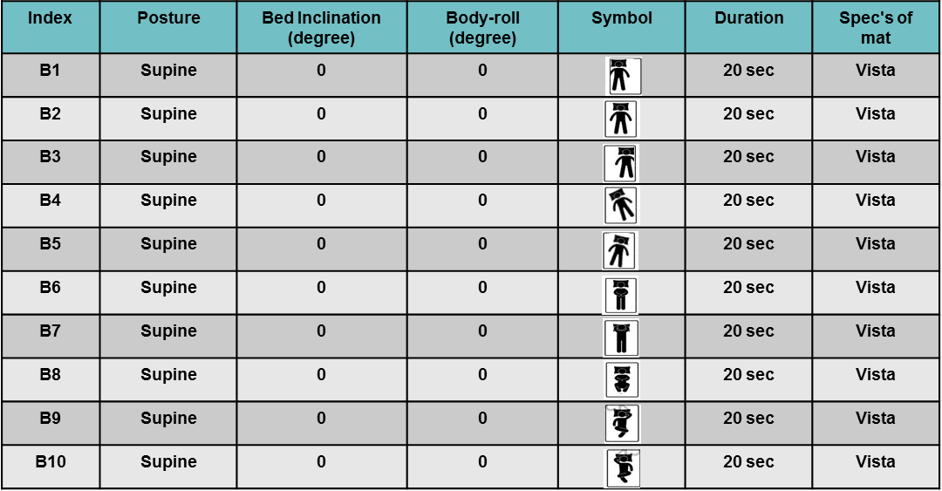

  - Part C:

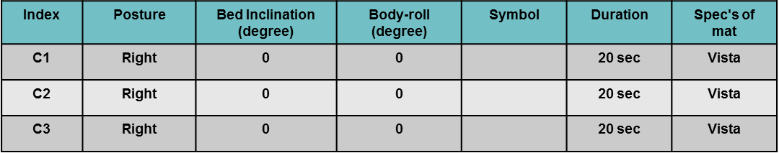

  - Part D:
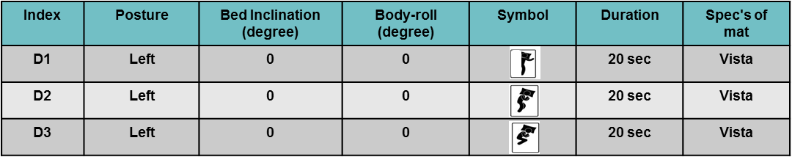

  - Part E:
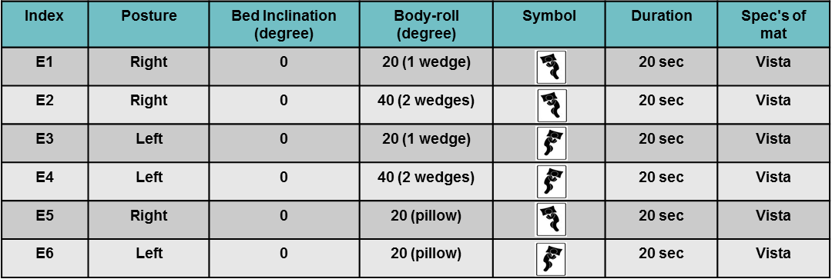
  - Part F:
